**BASIC**

1. How will you display different images based on the status being red, amber, or green?
2. How will you toggle image and enable/disable buttons conditionally?
3. How will you loop through a collection and list each item?
4. Create a simple directive that you can reuse across the application.
5. Write a simple Angular JS app that would fadeIn and FadeOut an image (using angular and css3 - hint:use ng-class)
6. Create a custom filter: a) capitalize first letter of each word, b)reverse the string

**INTERMEDIATE**

1. Create a custom directive that would take different for each directive (ISOLATES the scope of each directive).
2. Make a simple Carousel using Angular only. (Try Carousel from Angular UI for reference only).
3. Write code to fetch Customer Info from JSON file and display in a tabular format.
4. How will you display in-progress revolving image to indicate that RESTful data is bing loaded?
5. Write DELETE ROW functionality for each record in the AJAX-driven Table. Also develop a UNDO feature.
6. Write ADD ROW functionality for the above AJAX-driven TABLE.

**ADVANCED**

1. Write an app that would fetch data from a Cross domain URL [Rotten Tomatoes] and update the page with 10 different data points.
2. Create a TODO list that looks like this:

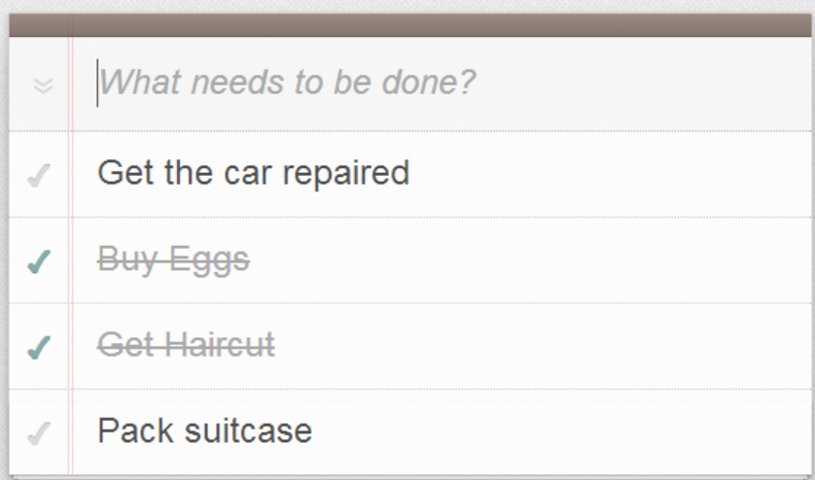

1. Build an AJAX driven table that includes SEARCH, SORT and PAGINATION

